A Case for Water Quality

Written by Skylee Shaffer, Education Specialist (2023)

Based on real data from Edge of Field Project

The Center for Earth & Environmental Sciences has been monitoring the Upper White River Watershed for many years. The Upper White River Watershed (UWRW) consists of seventeen smaller watersheds and includes more than 2,180 miles of steam and drainage area and spans sixteen central Indiana counties. The UWRW feeds four drinking water supply reservoirs including Geist Reservoir, Morse Reservoir, Prairie Creek Reservoir, and Eagle Creek 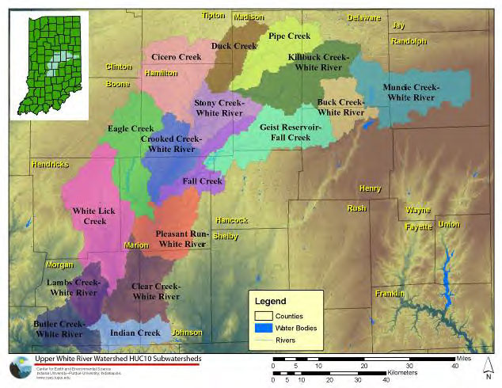Reservoir.

Due to its importance as a direct input into a drinking water reservoir for Indianapolis, the Eagle Creek Watershed has received a lot of attention in the past several years. Potentially hazardous water quality issues such as elevated levels of nitrogen, phosphorus, and pollutants began happening downstream of the Eagle Creek Reservoir. Subsequent studies illustrated just how widespread and complex many of these water quality issues are and their impact on the city's drinking water.

While the majority of the land that drains into the Upper White River Watershed is used for agriculture, mostly corn and soybean fields, the watershed is also experiencing rapid expansion of urban and suburban areas.

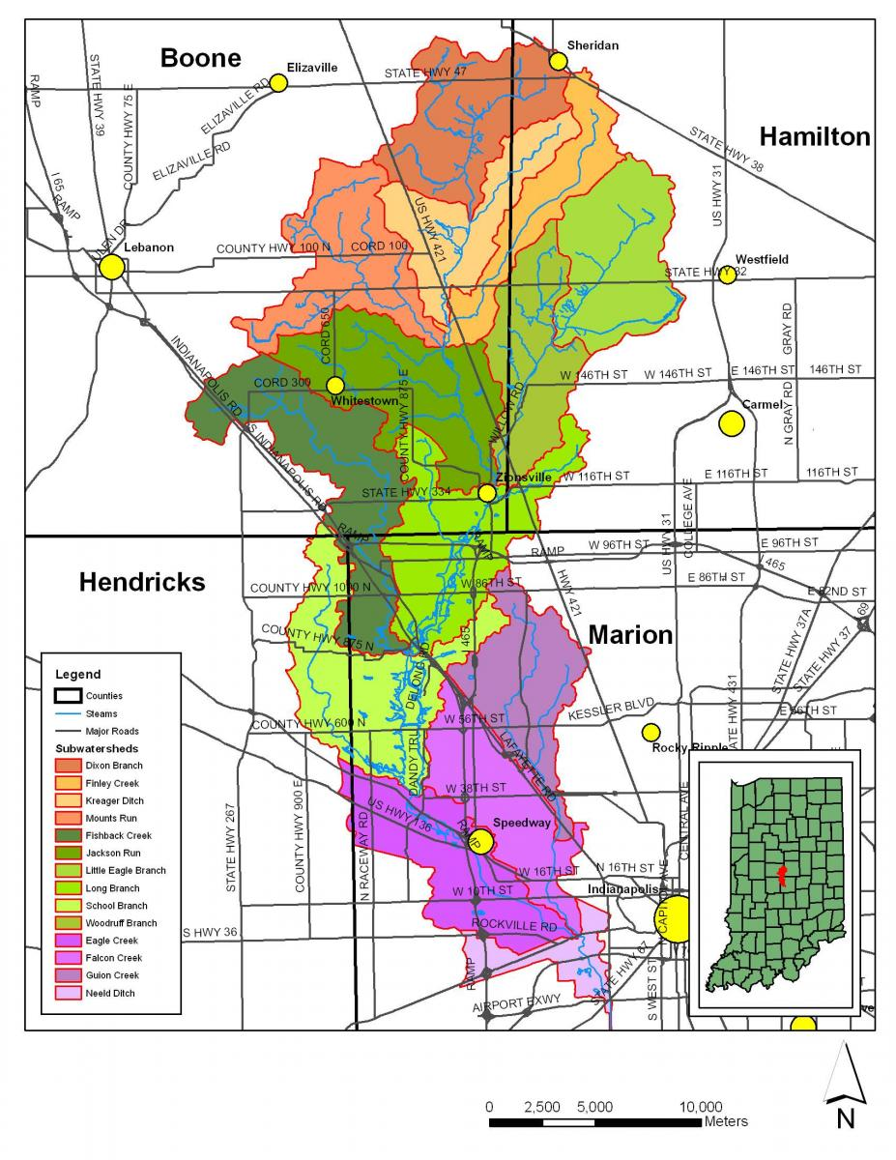To better quantify the effects of agricultural practices on water quality and quantity, the Natural Resource Conservation Service (NRCS) has developed a new national program, Edge-of-Field (EOF) sampling. In this program the NRCS contracts with farmers to directly monitor water quality in their fields. The first EOF project in Indiana is at Starkey Farms in the School Branch watershed (a subwatershed of the Eagle Creek watershed).

One component of the EOF project is to monitor nutrients that runoff into the watershed. Excess nutrients can cause harmful algae blooms. ​​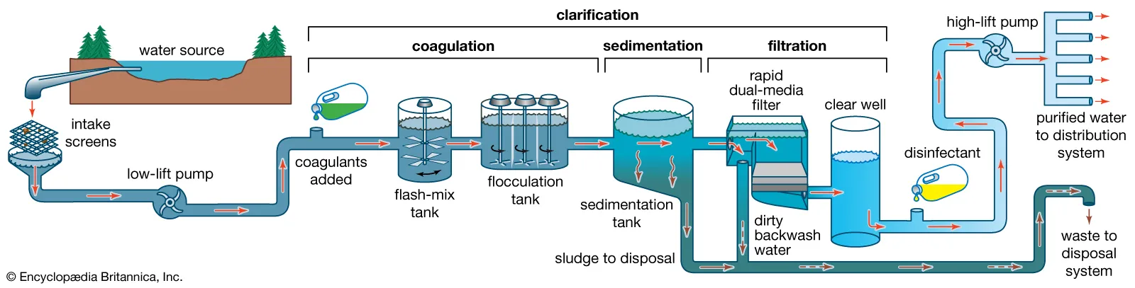Conventional water treatment can generally remove cyanobacterial cells and low levels of toxins. However, water systems may face challenges providing drinking water during a severe bloom event, when there are high levels of cyanobacteria and cyanotoxins in drinking water sources. If high levels of cyanotoxins occur in tap water, people are at risk of various adverse health effects including upset stomach, vomiting and diarrhea as well as liver and kidney damage.

This case study will focus on nutrients from agricultural fields in the School Branch Watershed and its impact on Eagle Creek Reservoir drinking water and on farmer’s yields.

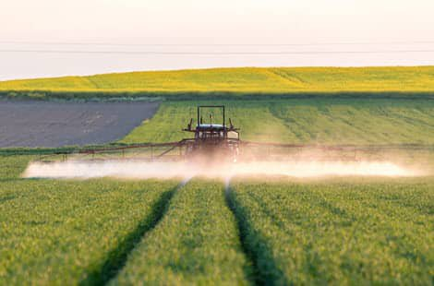In order to optimize crop yields, farmers apply fertilizers, with nitrogen promoting lush vegetation and phosphorus supporting flowering and fruit production. Fertilization typically involves mechanical spraying of nutrients onto crops. This method, along with plowing and manipulation of nutrient-rich topsoil, can significantly impact local watersheds.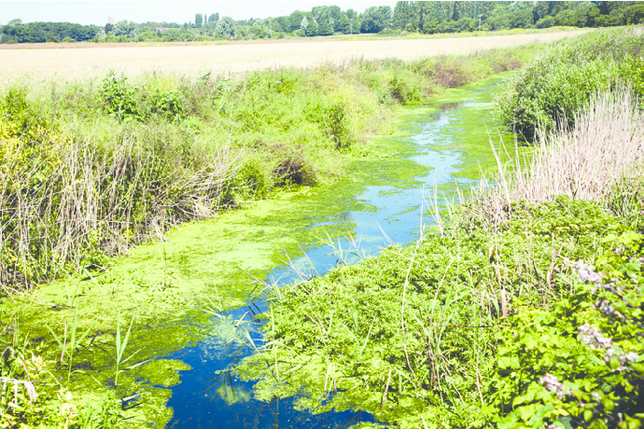

Tillage with mold plows and subsequent heavy machinery use can compact soil, reducing its water-holding capacity. Compacted soil impedes fertilizer absorption, leading to runoff during precipitation events. Excess nutrients, particularly nitrogen and phosphorus, enter nearby ditches, streams, and reservoirs like Eagle Creek, posing serious risks to water quality. These nutrients can stimulate algae growth, causing blooms that contribute to eutrophication, deplete water oxygen levels, and 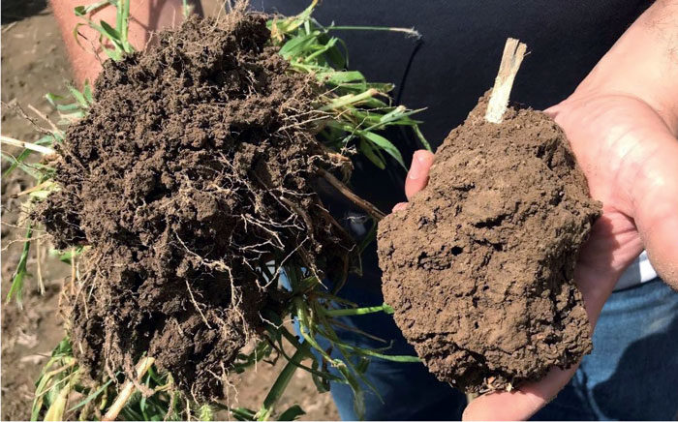creating dead zones.

Adopting sustainable agricultural practices, such as no-till farming, helps maintain soil structure and pore spaces. No-till soil retains water and facilitates fertilizer percolation. In contrast, conventional tilled soil becomes compacted, preventing water infiltration and promoting runoff. The image to the right has two different soil samples. The soil sample on the left is from a no-till operation. This soil contains pores and spaces for water and nutrient infiltration. While the soil sample on the right is from a conventional field. Notice the compaction of the soil. This results from tiling and heavy machinery. Water cannot infiltrate this soil and instead runs over the surface removing the vital nutrients and topsoil.

Additional practices like bioswales can be implemented to mitigate soil and nutrient runoff into waterways. Bioswales, featuring native grasses and pollinator plants, intercept excess nutrients and sediments, thereby reducing the risk of algae blooms and dead zones.

The EoF study includes Maloney Farm and Starkey Farm, both situated within the Schoolbranch watershed. Maloney Farm employs conventional farming methods, while Starkey Farm practices conservation techniques.

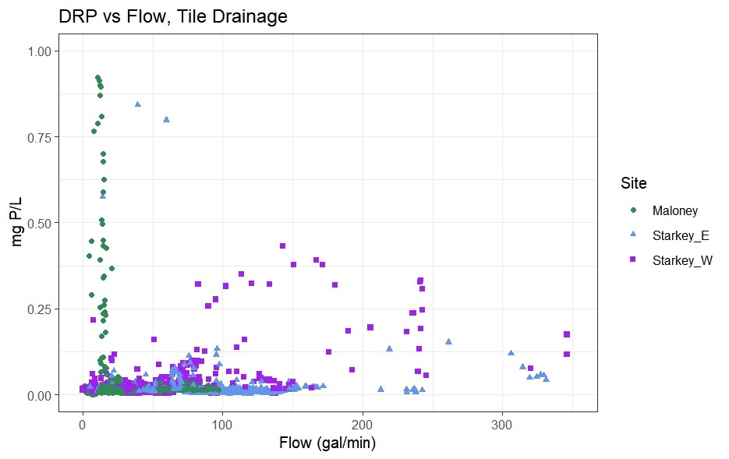

The graph above shows phosphorus that has been deposited in the Schoolbranch stream system. Phosphorus export due to tillage practices is usually associated with particulate phosphorus found in sediments. These sediments move over the field or through the field tile and into the water. Maloney’s farm employs traditional tilling practices, while Starkey uses conservational no-till practices.

The graph below shows the nitrate that has flowed from the fields. 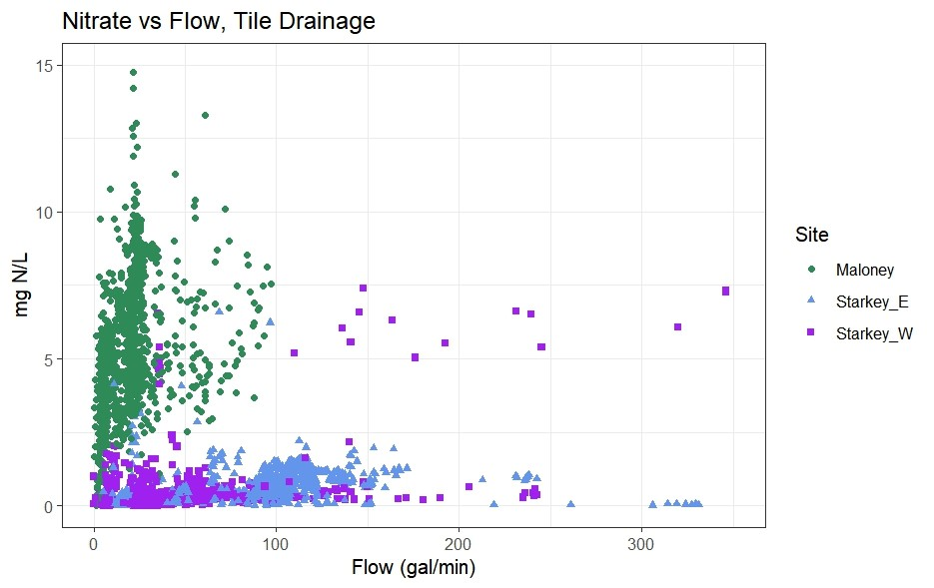

1. Based on the graph, what do you notice about the difference in phosphorus from Maloney’s farm compared to Starkey’s Farm?
2. Based on the graph, what do you notice about the difference in nitrates from Maloney’s farm compared to Starkey Farm?
3. Based on the reading, what would cause the big difference between Maloney’s and Starkey’s farm? What specific practices would lead to this amount of phosphorus and nitrate in the water? Draw or explain.

Resources for Teachers:

* <https://www.notill.org/mike-starkey>
* <https://www.starkeyfarmspartnership.com/about>
* <https://www.epa.gov/sites/default/files/2016-11/documents/harmful_algal_blooms_and_drinking_water_factsheet.pdf>
* <https://www.usgs.gov/centers/upper-midwest-water-science-center/science/edge-field-monitoring>