**Soil Erosion and Sustainable Agriculture**

**Prior to the lab:**

1. Have students collect soil samples from a location of their choice. Be sure to give them suggestions. Give them suggestions of where they could obtain the samples.
   1. From their homes
   2. From a park
   3. From a garden
   4. From the side of a road (highway/town road)
   5. In an urbanized area
   6. Near a river/waterway
   7. Etc.
2. The students should be able to fill up a sandwich-sized Ziploc bag.
3. Make sure to note that their samples should not be limited to only soil. Samples can include but don’t have to include:
   1. Mulch
   2. Grass clippings
   3. Weeds
   4. Small plants
   5. Corn husks
   6. Leaves
   7. Wood chips
   8. Twigs
   9. Roots of plants/grass
   10. Etc.

**Purpose of the Lab:**

Students will learn about soil erosion and understand how the amount of soil erosion can be impacted by several factors. Students will test their erosion and runoff theories to make valid

explanations and conclusions based on the results, and they will analyze the factors that impact soil erosion and recommend strategies to reduce or limit soil loss.

**Materials and Preparation:**

* Soda bottles (2-liters) (1 per student)
* Clear plastic cups (1 per student)
* Scissors
* Soil
* Leaves
* Mulch
* Grass clippings, different types of plants/weeds, mulch, etc.
* Some kind of container that the bottles can sit in horizontally (can be a container for a group, partners or individuals

**Indiana State Standards Alignment (2022)**

* HS-ESS2-1. Develop a model to illustrate how Earth’s internal and surface processes operate at different spatial and temporal scales to form continental and ocean-floor features.
* HS-ESS2-5. Plan and conduct an investigation of the properties of water and its effects on Earth materials and surface processes.
* HS-ESS3-1. Construct an explanation based on evidence for how the availability of natural resources, occurrence of natural hazards, and changes in climate have influenced human activity.
* HS-ESS3-3. Create a computational simulation to illustrate the relationships among management of natural resources, the sustainability of human populations, and biodiversity.
* HS-ESS3-4. Evaluate or refine a technological solution that reduces impacts of human activities on natural systems.
* HS-ESS3-6. Use a computational representation to illustrate the relationships among Earth systems and how those relationships are being modified due to human activity.
* HS-ENV1-2.* Use a computational representation to illustrate that humans are part of Earth's ecosystems and how human activities can, deliberately or inadvertently, alter ecosystems
* HS-ENV1-3. Use a computational representation to illustrate the relationships among Earth systems and how those relationships are being modified due to human activity.
* HS-ENV1-6.* Use a model to locate and describe the major Earth biomes. Analyze data to assess how biomes are determined by climate (temperature and precipitation patterns) that support specific kinds of plants.
* HS-ENV3-1.* Construct an explanation based on evidence for how natural Earth hazards, such as earthquakes, tornadoes, and hurricanes, affect the environment and human activity on both a short-term and long-term scale.
* HS-ENV5-2. Create a computational simulation to illustrate the relationships among management of natural resources, the sustainability of human populations, and biodiversity.
* HS-ENV5-3. Design, evaluate and refine a technological solution that reduces impacts of human activities on natural systems.
* HS-ENV5-4. Use a computational representation to illustrate the relationships among Earth systems and how those relationships are being modified due to human activity.
* MS-LS2-1. Analyze and interpret data to provide evidence for the effects of resource availability on organisms and populations of organisms in an ecosystem.
* MS-LS2-5. Evaluate competing design solutions for maintaining biodiversity and ecosystem services.
* MS-ESS3-2. Analyze and interpret data on natural hazards to forecast future catastrophic events and inform the development of technologies to mitigate their effects.
* MS-ESS3-3. Apply scientific principles to design a method for monitoring and minimizing a human impact on the environment.
* MS-ESS3-4. Construct an argument supported by evidence for how increases in human population and per-capita consumption of natural resources impact Earth's systems.
* APES: ERT-4.B Describe the characteristics and formation of soil.
* APES: ERT-1.D Explain the steps and reservoir interactions in the carbon cycle.
* APES: ERT-1.E Explain the steps and reservoir interactions in the nitrogen cycle
* APES: ERT-4.C Describe similarities and differences between properties of different soil types.
* APES: STB-1.E Describe sustainable agricultural and food production practices
* Ag: IAFNR-4.3 Identify the physical qualities of the soil that determine its use
* Ag: IAFNR-5.1 Explain interrelationships between natural resources and humans necessary to conduct conservation practices in natural environments
* Ag: IAFNR-5.2 Summarize the relationship between natural resources, ecosystems and human activity
* Ag: IAFNR-5.3 Identify natural resources and their importance to the local community.
* Ag: IAFNR-9.1 Examine and categorize current applications and gains achieved in applying biotechnology to agriculture.

**Lab Worksheet**  Name __________________

**Background:**

Waves, wind, water, and glaciers shape and reshape Earth’s surface by gradually wearing away (eroding) the rocks and soil. Through these processes, the material that makes up Earth’s crust is moved from one place to another. When it rains, water that is not used by plants or dried up by the sun slowly flows through the topsoil downhill into nearby water basins (lakes, rivers, streams, aquifers, etc.). When the flow of water is slow, land changes and erosion occur very slowly over time. If the flow of water in the topsoil is rapid, then changes to the landscape may occur rapidly as well. One example of this rapid movement of topsoil is a landslide.

Soil is rich in nutrients, detritus (dead organic matter such as wood chips and leaves) and sometimes may even contain harmful pesticides (man-made chemicals to control weeds and insects). All of these things contained in soil can be carried by land runoff and eventually pollute our waterways that we rely on drinking water. In areas where the land is poorly managed, too much soil erosion can occur which leads to poor water quality. In this activity you will explore how water runoff affects the transport of topsoil and water quality under different land conditions.

**Essential Question**: How is soil a valuable resource and what are humans doing to change soil quality?

**Student Outcome:** Model how weathering and erosion affect soils and their ability to produce crops.

**Pre-Lab:**

1. Examine your soil sample. In the following table, describe its color, texture, moisture, and smell. Does your sample only include soil? If not, what else is in your sample?

|  |
| --- |

1. Make a prediction about your soil sample. Do you think your soil sample is apt to resist erosion during a rainstorm? Why?
2. If you think your sample is apt, what qualities about the sample make you predict that?
3. Examine your lab partner’s (or lab group’s) collected soil sample(s). Repeat the directions from question 1. Also, how do their samples differ from your sample?
4. If you think the sample is apt, what qualities about the sample make you predict that?
5. Make a prediction about your partner’s soil sample (or someone in the group). Do you think their soil sample is apt to resist erosion during a rainstorm? Why?

**Soil Erosion Lab**

1. Use scissors to cut a large rectangle out of the side of each soda bottle.
2. Place the bottles on their sides on a stool or upside-down container to lift them a few inches off of the ground.
3. Place a clear plastic cup under the neck of each bottle. If the cup is too tall for water to pour into it from the soda bottle, then use scissors to trim the plastic cup and make it shorter. Make sure you don’t cut the cups too short – they need to have enough room to hold the water you will pour into the soda bottles.
4. The set-up should look similar to the image below:

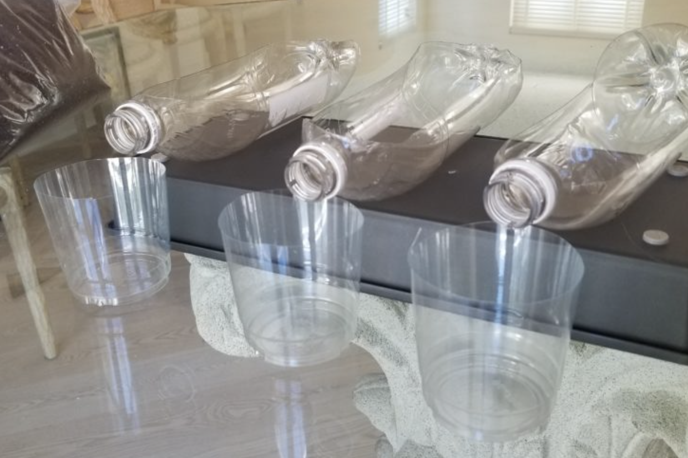

1. Fill the soda bottle with the soil you collected. If soil contains other materials (leaves, mulch, twigs, grass, etc.), pack the soil firmly into their containers. If your sample only includes soil, leave it loose in the soda bottle.
2. Your sample could look like the following:

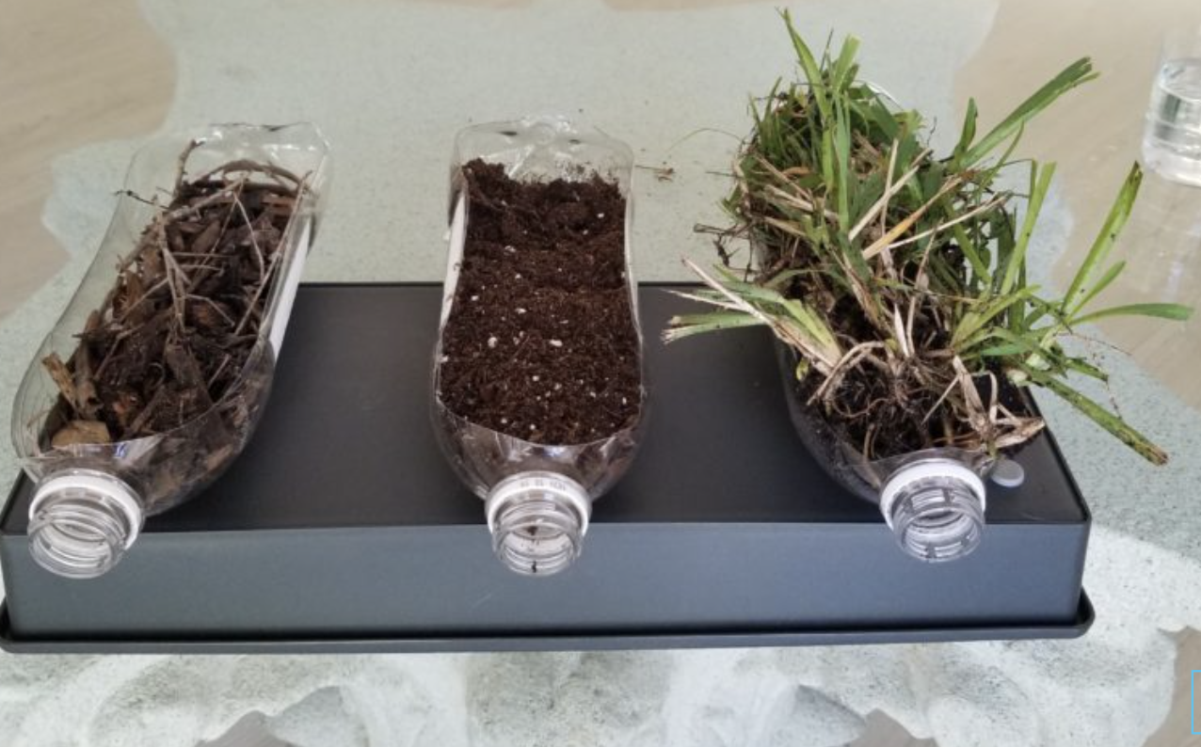

1. Pour water very slowly from a pitcher and watch as the water passes through the soil and flows into the water reservoir (plastic cup). Try to cover the entire surface rather than just pouring the water in one spot.
2. Observe how much soil erodes from each container and flows into the plastic cups. Write your initial observations in the table below

| Initial Observations |
| --- |
|  |

**Post Lab**

1. Between your soil sample and your partner’s (or between the group), which soil sample had the **least** amount of runoff? Why do you think? Use evidence from your observations from the pre-lab.
2. Between your soil sample and your partner’s (or between the group), which soil sample had the **most** amount of runoff? Why do you think? Use evidence from your observations from the pre-lab.
3. Human activities such as cutting down trees/removing vegetation or disturbing the ground (e.g. plowing), are activities that may increase erosion. As you saw in your experiment with the soda bottles, when we remove too many plants from an ecosystem, there can be negative side effects such as reduced water quality. When the water flowed into the plastic cups, you may have noticed a difference in the color of the water coming out of the soda bottles. The soda bottle(s) (if any) that had plants should have produced the clearest water in the plastic cup because the shoots of grass protected the soil below from the water falling from above, and also because the upper layer of soil is held together by the roots of the plants. If no one in your group had plants within their soil, go observe another group’s experiment.

What do your and your group’s results suggest about the different types of ground cover and how they work to prevent erosion? What recommendations would you make to help prevent erosion?