A Case for Soil Health

Written by Skylee Shaffer, Education Specialist (2023)
Based on real data from Edge of Field Project

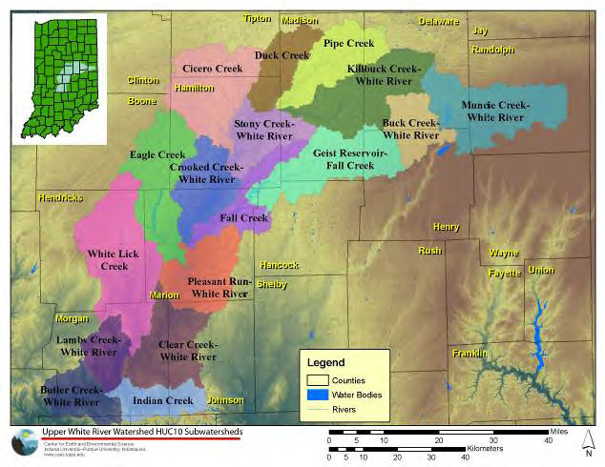
The Center for Earth & Environmental Sciences has been monitoring the Upper White River Watershed for many years. The Upper White River Watershed (UWRW) consists of seventeen smaller watersheds and includes more than 2,180 miles of steam and drainage area and spans sixteen central Indiana counties. The UWRW feeds four drinking water supply reservoirs including Geist Reservoir, Morse Reservoir, Prairie Creek Reservoir, and Eagle Creek Reservoir.
Due to its importance as a direct input into a drinking water reservoir for Indianapolis, the Eagle Creek Watershed has received a lot of attention in the past several years. Potentially hazardous water quality issues such as elevated levels of nitrogen, phosphorus, and pollutants began happening downstream of the Eagle Creek Reservoir. Subsequent studies illustrated just how widespread and complex many of these water quality issues are and their impact on the city's drinking water.
While the majority of the land that drains into the Upper White River Watershed is used for agriculture, mostly corn and soybean fields, the watershed is also experiencing rapid expansion of urban and suburban areas.

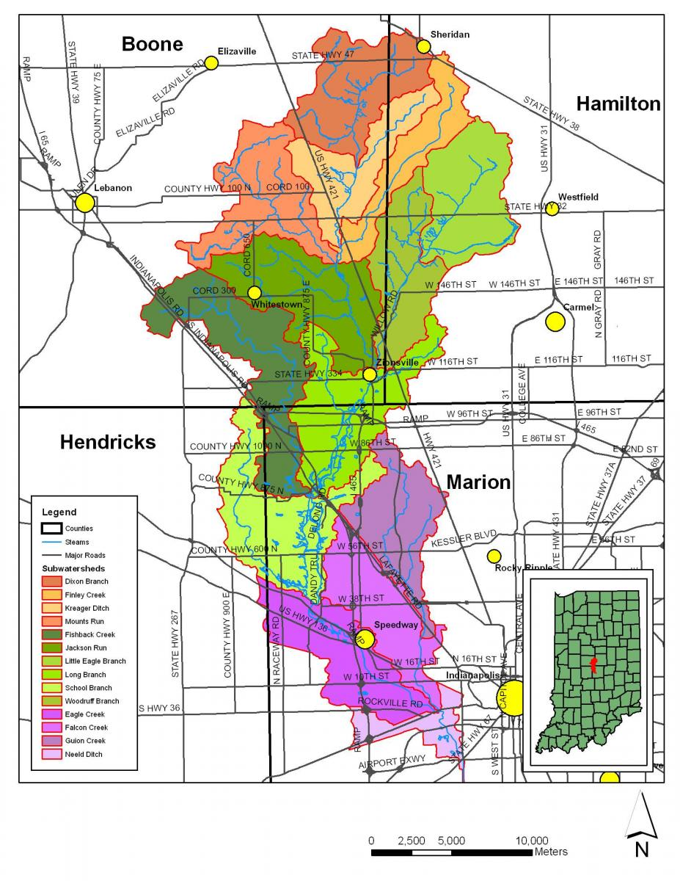
To better quantify the effects of agricultural practices on water quality and quantity, the Natural Resource Conservation Service (NRCS) has developed a new national program, Edge-of-Field (EOF) sampling. In this program the NRCS contracts with farmers to directly monitor water quality in their fields. The first EOF project in Indiana is at Starkey Farms in the School Branch watershed (a subwatershed of the Eagle Creek watershed).
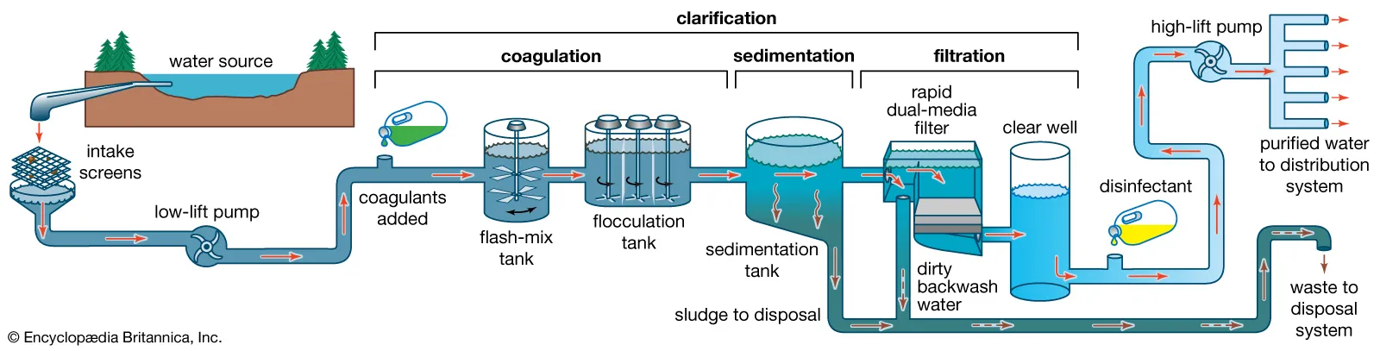
One component of the EOF project is to monitor sediments that runoff into the watershed. Sediments come from agricultural fields, construction sites, roads, and any other source of bare dirt. Excess sediments in drinking water can be costly. It takes more time and energy to remove the sediments from the drinking water. In addition, sediments can impact the taste and smell of drinking water. This case study will focus on sediments from agricultural fields in the School Branch Watershed and its impact on Eagle Creek Reservoir drinking water and on farmer’s yields.
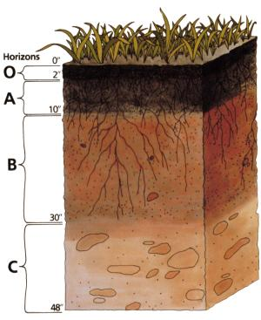
Sediments from agricultural fields originate from the top layer of soil, often called topsoil or A Horizon. The image below shows the various layers of soil. The O Horizon is formed from organic matter from decomposing plants and is the top most layer of the soil. However, the A Horizon is the accumulation of organic material from decomposing plants, animals and microbes over a long period of time. This is a very nutrient rich layer and even though it might not be the top most layer of the soil horizons, is called the topsoil. Topsoil is very important for plant growth and where plants obtain nitrogen, phosphorus, and potassium. Nitrogen is associated with lush vegetation, while phosphorus helps the plants bloom and produce fruit and seeds. Potassium is necessary for durability and disease resistance (NRCS) All of these nutrients can be found in a mature topsoil. However, farmers often need to add fertilizer to their crops because of reduced nutrients in the soil. Reduced nutrients can occur due to conventional farming practices and topsoil erosion during heavy rain events.
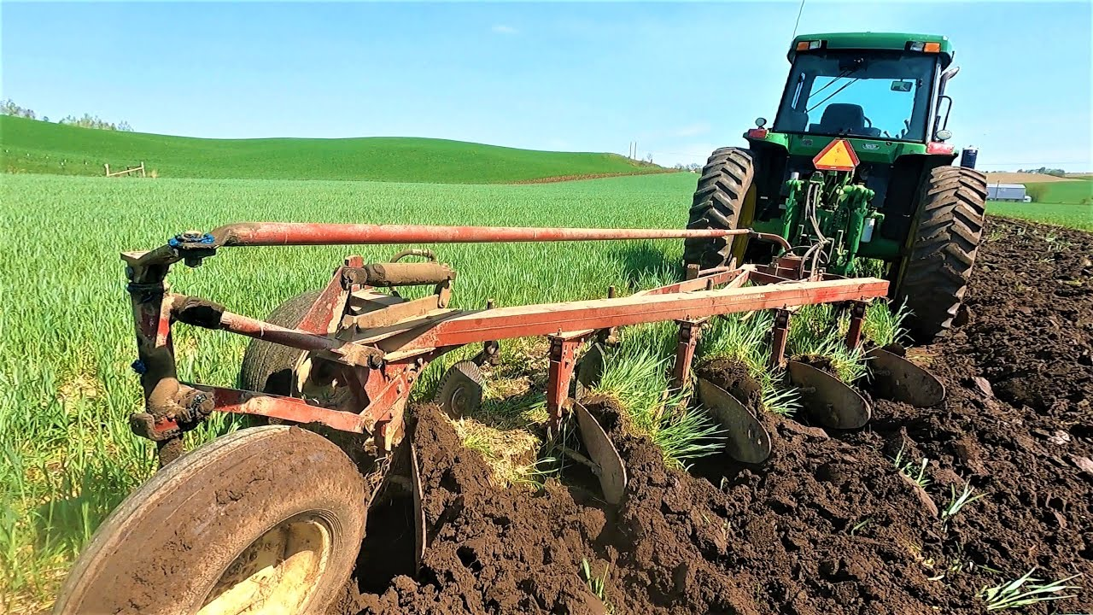
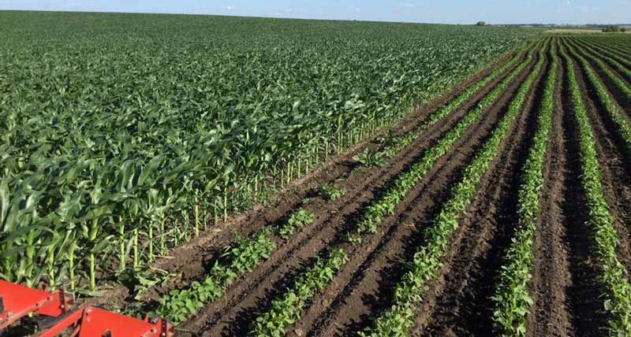
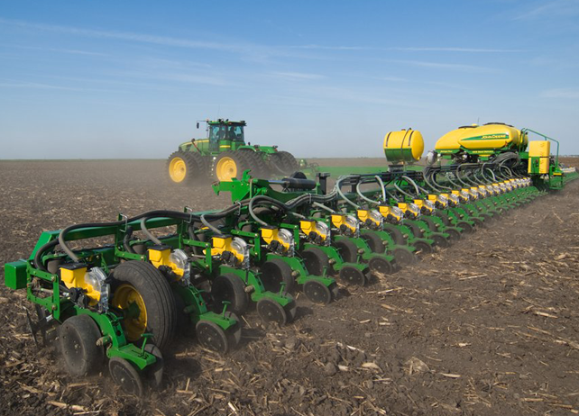
According to the U.S. Department of Agriculture conventional planting practices involve inverting the soil with a moldboard plow. This turns in the existing ground cover and provides loose soil in which to plant the seeds. The soil is left bare and exposed to the elements until the crop grows. This method contributes to topsoil erosion during precipitation events. During a heavy precipitation event water, topsoil, and the nutrients it contains, can flow through the field tile or over the field surface. This can impact the amount of nutrients left on the field and eventually impact the yield, or the amount of crop that is produced from the field.
Tilling the land with a plow
Planting the seeds
3. Crops begin to grow
Two farms have been involved in the EOF study; Maloney Farm and Starkey Farm. Both farms are along the Schoolbranch watershed. Maloney Farm employs conventional farming practices as mentioned above. Starkey Farm employs conservation practices. Conservation farming practices include no-till and cover crop. No-till means that Starkey does not turn the soil prior to planting. Starkey plants a cover crop of annual ryegrass to cover the soil during the winter months when the corn and soybeans are not in season. Once it is time for planting, he uses a special piece of equipment that punches a hole in the soil and plants the seeds.
Both of these farms have been monitored for the last several years to see if the different farming practices have any effect on soil health and thereby crop yields.

No Till (Starkey) |  |  |  | Conventional (Maloney)
Time since start of runoff, minutes | Sediment concentration, mg L⁻¹ | Water flow,  L min⁻¹ |  | Time since start of runoff, minutes | Sediment concentration, mg L⁻¹ | Water flow,  L min⁻¹
0 | 0.1 | 0.4 |  | 0 | 0.2 | 0.4
30 | 111 | 177.6 |  | 34 | 68 | 133.3
45 | 74 | 129.1 |  | 36 | 114 | 133.3
240 | 25 | 69.6 |  | 49 | 68 | 6.6
540 | 55 | 28.4 |  | 51 | 48 | 6.6
900 | 36 | 11.2 |  | 64 | 51 | 635.1
 |  |  |  | 66 | 53 | 635.1
 |  |  |  | 79 | 55 | 1351.5
 |  |  |  | 109 | 30 | 1796.3
 |  |  |  | 289 | 10 | 25.4

The sediment concentration measured above is the amount of sediments found to be running off the fields, either through the field tiles, or over the field into the nearby School Branch Stream.
Notice the concentration of the sediments from Maloney’s farm stayed much higher for longer. This means that more fertile topsoil was lost from Maloney’s fields than Starkey’s. This loss of topsoil has a lasting impact on yield (the amount of crops a farmer can get from their farm). A decrease in yield means a decrease in profits.
Over time, as the soil is continuously bombarded by heavy precipitation events the topsoil can completely wash away and a farmer might be forced to abandon the field. This has an impact on food prices. The less space farmers have to grow food the lower the supply, this coupled with a rise in population of the planet increases the demand. As a result food can become more expensive.
It is important to protect soil as a resource in order to continue feeding the people.
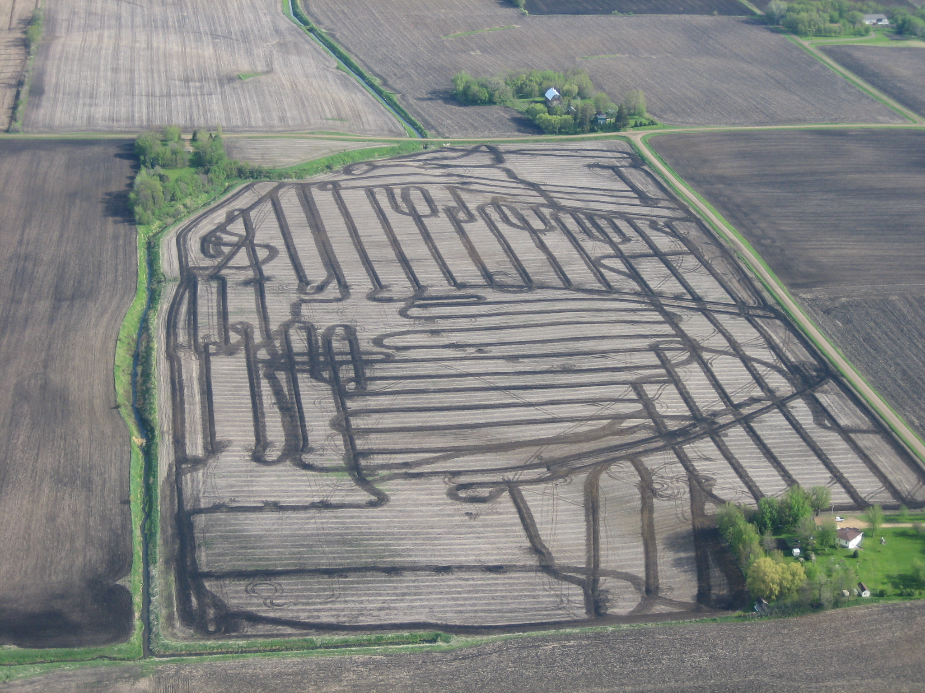
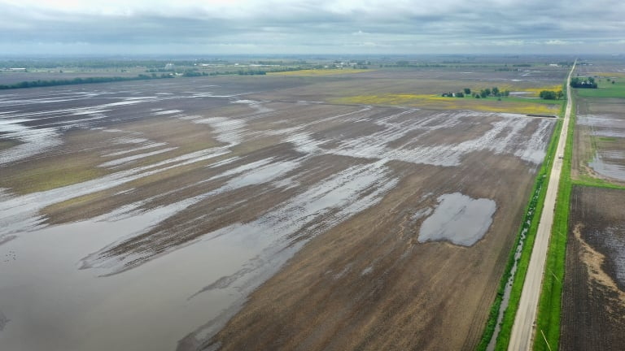
A field tile is an underground drainage system that allows water to percolate through the topsoil of the field and removes excess water, and sometimes sediments to the nearest drainage ditch or river.
During heavy precipitation events the field tile may not be able to move enough water off the field. This allows more water to flow over the surface. More sediments are lost this way.
Analysis Questions:
- On the next page graph the data you see above. Make time the x-axis (minutes), and sediment concentration on the y-axis.

- Calculate average concentration of sediment (mg L⁻¹) for each tillage practice. Is there a difference between the two practices?

- Why is there a difference between the sediment concentrations of the no-till and conventional farm field? What are the farmers doing differently that impacts the sediment concentration?

- What are the other benefits of no-till sustainable agriculture?

- What suggestions would you make to Maloney in order to increase his yield and reduce topsoil erosion?

Resources for Teachers:
- https://nrcspad.sc.egov.usda.gov/DistributionCenter/pdf.aspx?productID=47#:~:text=Nitrogen%20is%20associated%20with%20lush,are%20referred%20to%20as%20macronutrients.
- https://www.notill.org/mike-starkey
- https://www.starkeyfarmspartnership.com/about
- https://www.youtube.com/watch?v=HfCH78XieO4
- https://www.youtube.com/watch?v=NJhpoYwAqFA
- https://www.youtube.com/watch?v=bQy1YQxH_TY

