Written by: Skylee Shaffer, Education Specialist (2023)
Title of Lesson: Matter Cycles in the Hydrosphere
Type of Lesson: Introductory, Direct Instruction, Discussion

Description of lesson: This program is the third lesson in the Water Conservation Module. It is intended to be completed after the Virtual Water Activity and the Water Cycle Lesson. However, if your students are comfortable knowing how the water cycle works and how climate change is affecting it, this would be a great lesson to fit into your curriculum when talking about biogeochemical cycles.
This lesson covers the Phosphorus, Nitrogen, and Carbon Cycle as it relates to water. Students will explore how Nitrogen, Phosphorus and Carbon Dioxide interact with water systems and the impacts they have on the overall water quality. Students will explore human impacts to this system as well as mitigation strategies and their effects on the biogeochemical cycles.
Included in this lesson are two labs: Ocean Acidification Lab and Eutrophication Lab
Enduring Understandings:  Water is crucial for habitability. Humans are impacting water resources in various ways including agriculture, industry, and human caused climate change. | Essential Questions:  If water is always cycling, why should we care about water conservation?  How is water a valuable resource and what are humans doing to change water quality?
Academic Standards:  - HS-ENV4-2. Design, evaluate, and refine a solution for reducing the impacts of human activities on the environment and biodiversity.  - HS-ENV1-2.* Use a computational representation to illustrate that humans are part of Earth's ecosystems and how human activities can, deliberately or inadvertently, alter ecosystems.  - HS-ENV2-1.* Construct and revise an explanation based on evidence for the cycling of matter through sources and sinks and how energy is transferred.  - HS-ESS2-5 Plan and conduct an investigation of the properties of water and its effects on Earth materials and surface processes  - HS-ESS3-6 Use a computational representation to illustrate the relationships among Earth systems and how those relationships are being modified due to human activity.  - Ag:IAFNR-5.1 Explain interrelationships between natural resources and humans necessary to conduct conservation practices in natural environments  - Ag: IAFNR-5.2 Summarize the relationship between natural resources, ecosystems and human activity  - Ag:IAFNR-5.3 Identify natural resources and their importance to the local community.  - APES: ERT-1.G Explain the steps and reservoir interactions in the hydrologic cycle. | Student learning targets:  - Identify the role of water in other biogeochemical cycles  - Define Eutrophication and understand the role of fertilizer in creating dead zones  - Define Ocean Acidification and understand the role of burning fossil fuels in the process  - Define watershed and understand the connection of waterways and how fertilizer can get from fields all the way to the ocean  - Research mitigation strategies for ocean acidification and eutrophication and their impact on the biogeochemical cycles
Assessment task - During this lesson teachers will be using the following activities as forms of assessment
- Phosphorus, Nitrogen, and Carbon Cycle informal pre-assessment
  - Asking students to recall what they remember about these cycles from previous courses will give the teacher an idea of how in depth they need to go on this subject
  - Students who have taken Biology, Environmental Science, Earth Science and APES should have a basic understanding of these cycles as per the IDOE state standards
- Mitigation Strategy Whiteboard/Poster Activity (last slide)
  - Students should be split into groups
  - Half of the groups should research mitigation strategies based on ocean acidification and the other half should research strategies on eutrophication
  - Have students answer the following questions on a whiteboard or poster
    - Describe the strategy (what are people doing)
    - What are the pros and cons of this?
      - Is it all good? Why might people not want to do this? Why would people want to do this?
    - How do you think cities and states will implement these suggestions? How will they convince the people to do it
    - Is there a cost involved? Time or money?
  - Finally have students draw how this mitigation strategy will change the phosphorus, nitrogen, or carbon cycle. This final step ensures that students are taking what they learned and applying it in a new situation - DOK 3
Differentiation:  - High achieving students should be encouraged to complete the labs instead of demos  - Classroom discussion can be done as a Think-Pair-Share if students are not comfortable sharing out as a whole class  - In addition, journal entries or online discussion boards could be used as well. | Accommodations:  - A guided note sheet could be provided for students to write the answer to the discussion questions for easy recall later  - Labs can be chunked into smaller sections with frequent check-ins  - Human Impact Whiteboard/Poster activity can be done as a worksheet for students who struggle working in groups.
Prior Learning:  - A basic knowledge of the phosphorus, nitrogen, and carbon cycle  - Understanding of the water cycle | Prerequisite skills:  - Lab safety and skills  - Reading directions  - Discussion protocol (think, pair, share)
Materials  - Whiteboards  - Poster paper  - See below for materials for the labs/demos | Technology:  - Presenter  - Youtube  - Smartphone for pictures of microscope slides
Vocabulary Development:
- Watershed
- Eutrophication
- Ocean acidification
- Dead zones
- Fertilizer
- Algae blooms
- Mitigation
Procedures:
- Download the PowerPoint from the CEES Website: https://cees.iupui.edu/education-programs/k-12/teacher-resources/sustainable-agriculture.html
- Follow the PowerPoint as a guide for discussion and classroom pacing. Use the following guide for resources and information
  - Carbon, Phosphorus, and Nitrogen cycle
    - Slides 3,4, and 5 have various matter cycles. Possible student answers are on the slides as animated text boxes. The slides can be printed ahead of time without the possible answers for students to work as a group and come up with their own answer. Alternatively, students can do one slide at a time on a whiteboard before being shown the answers by the teacher.
  - How do these impact the hydrosphere when they are out of balance
    - Ocean Acidification
      - The following slides (7-9) cover the imbalance in the carbon cycle and how it impacts ocean acidification
      - To learn more about this concept check out the follow resource
        - https://www.noaa.gov/education/resource-collections/ocean-coasts/ocean-acidification
        - It is important to note that acidification can occur in freshwater systems as well
      - https://www.youtube.com/watch?v=gZGj0BbDT38
    - Eutrophication
      - The following slides (11-13) in the powerpoint cover how the imbalance of the nitrogen and phosphorus cycle contribute to eutrophication and dead zones.
      - If you are unfamiliar with this concept - check out the following resources
        - https://oceanservice.noaa.gov/facts/eutrophication.html
      - It is important to note that phosphorus typically affects freshwater ecosystems and nitrogen affects saltwater ecosystems
      - Dead Zone - Can the ocean run out of oxygen - Ted Ed
      - https://www.youtube.com/watch?v=ovl_XbgmCbw
  - Labs/Demos Teacher Notes:
    - These labs/demos can be done at a couple of different points during the lesson
      - After the bellringer, before the direct instruction
        - Placing the lab in this spot of the lesson allows students to have a phenomenon to base their learning upon. Students will be able to see the impacts of fertilizer and acidification before learning about it
      - After the direct instruction, before the human impact
        - Placing the labs/demos here would allow students to get a base knowledge of ocean acidification and eutrophication before seeing it in action. This might be the best place for students in lower grades.
  - Ocean acidification lab/demo
    - The following lab can be done as a demonstration - the labs can be downloaded from the CEES website
      - This demonstration/lab can be done in two ways and both will be described below
    - Dry Ice Method
      - Materials:
        - Dry Ice
        - Beaker
        - Vernier pH probe or pH strips
        - Lab Quest or Computer program
      - Procedure:
        - Fill a beaker with water and place it where students can see it
        - Insert the pH probe and discuss the pH of the water
        - Have students make predictions about what they think will happen when you drop the dry ice in the beaker
        - Explain to student what dry ice is - a misconception that has cropped up in my classroom has been that dry ice is like regular ice and will make the water colder
        - Monitor the pH probe with the students
        - Students can graph the data
    - Bromothymol Blue Method
      - Materials:
        - Bromothymol Blue
        - Sandwich bags (the smaller snack bags work great for this)
        - Straws
      - Procedure
        - Fill a small sandwich bag halfway with water
        - Add a dropper full of bromothymol blue (you want it to be pretty blue, but not so much that students take forever blowing into it)
        - Place a straw in the bag with one end sticking out. Seal the bag around the straw
        - Blow in the straw for 30 seconds and record any observations below
        - Continue to blow in the bag until the water changes to an acid
  - Eutrophication lab/demo
    - The following lab can be done as a demonstration - the labs can be downloaded from the CEES website
    - Materials:
      - 4 mason jars or glass beakers
      - Pond water with algae culture in it
      - Microscope and slides (to make sure there is algae in the pond water)
      - Liquid Plant fertilizer
      - Light source (sunny window)
      - Droppers or pipettes
    - Procedure:
      - The teacher can set this demo up ahead of time or have student design the experiment and run it over time - this should take about a 1-2 weeks for the algae to set up
      - If you are doing this activity as a demo set up the jars in the following way
        - Control jar - pond water with no fertilizer added
        - Pulse jar - give one teaspoon of plant fertilizer to the pond water and let it sit for 1-2 weeks
          - This represents a one time runoff event from a heavy storm overflow
        - Press jar - give smaller sustained treatments of plant fertilizer over the course of the time period - 1/4th of a teaspoon, 4 times over the same amount of time as your pulse jar
          - This represents a water source that is next to a farm that gets fertilizer often
        - Have students dip samples of the control, pulse and press jars and dropper them on microscope slides.
        - Have students count the number of algae they see on the slides
        - Alternatively you can take pictures of the slides through the microscope lens with a smartphone and have students count the algae
      - 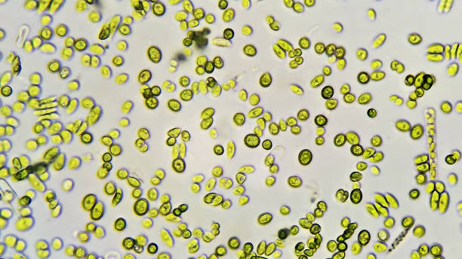
      - If there are too many algae to count as in the example below, alternatively students could use qualitative analysis and eyeball to see which sample has more algae
      - 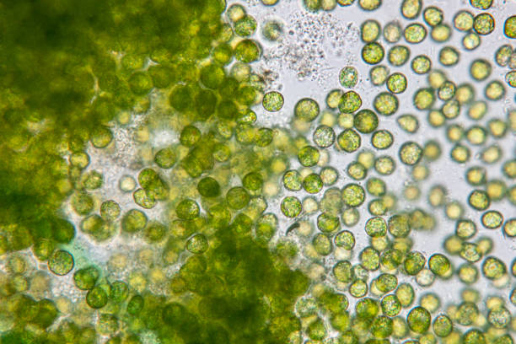
      - Be sure to dispose of algal cultures responsibly. Do not allow students to pour cultures down the drain without treating them first. To prepare cultures for safe disposal, do one of the following:
        - Add bleach to the culture to make a 1% solution; leave the bleached cultures to sit overnight and then pour down the drain with running water.
        - Bring the cultures to a boil in a microwave-safe container in a microwave oven. Although this may be accompanied by an unpleasant smell, it will not contaminate your microwave or make it unsafe for future food preparation.
    - Use the PowerPoint for sample discussion questions for the demo version or see the attached lab write-up for the full lab version
    - The student lab was adapted from a Carey Institute of Ecosystem Studies for college level students. The original lab can be found at the links below
      - https://www.caryinstitute.org/our-expertise/freshwater/harmful-algal-blooms
      - https://www.caryinstitute.org/sites/default/files/public/downloads/lesson-plans/4C3_eutrophication_worksheet.pdf
  - Human Impact
    - Slides 16-20 cover how humans are contributing to eutrophication and ocean acidification. Students will learn about watersheds and how their watershed is impacted by human activity
      - https://mywaterway.epa.gov/
      - For more information about watersheds and surface water see the watershed lesson on the CEES Teacher Resources web page
      - When asking students about what specific human impacts contribute to eutrophication and ocean acidification encourage students to be specific. I encourage you as the teacher to reach for more than just “burning fossil fuels” . Students need to know how those fossil fuels are burned so that they can understand the habits that contribute to this problem. When talking about topics such as human impact, it is important to stay away from vague terms like ‘burning fossil fuels’ and ‘pollution’ as they do not prompt actionable responses
    - The last slide in the PowerPoint asks students to find mitigation strategies to prevent the effects of eutrophication and ocean acidification. Students can create posters or do a whiteboard gallery walk of possible mitigation strategies
      - Possible mitigation strategies for teacher guidance
        - Reduce the amount of driving (reduction in carbon dioxide)
        - Reduce the amount of plastic being produced (plastic is made from fossil fuels)
        - Reduce the amount of food breaking down in a landfill, as that produces carbon dioxide
        - Don’t fertilize lawns with synthetic fertilizer, use compost or plant clover instead
        - Reduce the amount of fertilizer on golf courses (also the amount of sprinklers that turn on, as it’s the runoff of excess fertilizer)
        - Encourage and educate farmers about no-till practices which reduce the amount of runoff and the amount of fertilizer needed.

Attach:

Matter Cycling in the Hydrosphere PPT
Eutrophication Lab/Demo
Ocean Acidification Lab/Demo

