Eutrophication Lab

Background: Eutrophication is a complex environmental process driven by excessive nutrient inputs, leading to profound changes in aquatic ecosystems. In this lab, we will explore and model the mechanisms behind eutrophication, aiming to understand its causes, effects, and potential mitigation strategies.
Eutrophication occurs when nutrients, primarily nitrogen and phosphorus, accumulate in aquatic environments, often due to human activities such as agriculture runoff, sewage discharge, and industrial processes. These nutrients stimulate the growth of algae and other aquatic plants, initiating a cascade of ecological changes that can have significant consequences for water quality, biodiversity, and ecosystem services.
Through this lab, you will gain hands-on experience in modeling eutrophication using simulation tools and data analysis techniques. Understanding eutrophication is crucial for developing sustainable management practices to protect and restore aquatic ecosystems worldwide.
Procedure:
- Obtain three mason jars (or other containers), pond water, a graduated cylinder, a microscope, slides and a pipette
- Fill each jar about half way with pond water (500-700 ml) - make sure you add the same amount of water to each jar
- Gently stir the water in the jar. Draw water into a dropper
- Place a drop of water on a microscope slide and find the algae. Count the number of algae on the slide
  - When counting algae it is important that you find a spot on the slides in the middle, counting on the edges could result in an unreliable number
  - Make sure to find the same spot on every slide and count only what is within the field of view.
- Record your initial algae count and other observations in the table below
- Set aside one jar and label it control. This jar will not be altered
- Of the remaining two jars label one PRESS and the other PULSE
  - Press Jar Set-up: add ¼ a teaspoon of liquid plant fertilizer
    - Over the next 1-2 weeks add 3 more ¼ tsp as regular intervals
  - Pulse Jar Set-up: add 1 tsp of liquid fertilizer, this will be the only time you add this
- Set all three jars in a sunny location- such as a windowsill or under a grow light
- Let the jars sit for 1-2 weeks - remember to continue to add the fertilizer to your PRESS jar ONLY.

Initial algae count and observations:

How many days have the algae jars been sitting?
Jar Treatment |  | Number of Algae observed under microscope | Color of Water | Other observations
Control
Press | Additional fertilizer treatment
Pulse

- One jar has a pulse treatment - this means it only got one big dose of plant fertilizer, what event in nature do you think this is modeling?

- One jar has a press treatment - this means it got 4 smaller doses of plant fertilizer over time. What event in nature do you think this is modeling?

- Why do we have to have a control jar?

- What is the impact that an algae bloom has on water quality? Would you drink it?

- How do you think humans would clean out the algae in order to make this into drinking water?

- What other impacts on the water systems can an algae blooms have?

- Imagine you are managing a local watershed. You need to ensure that the reservoir within your watershed remains viable as a drinking water source. What measures would you take throughout the watershed to maintain this level of water quality?

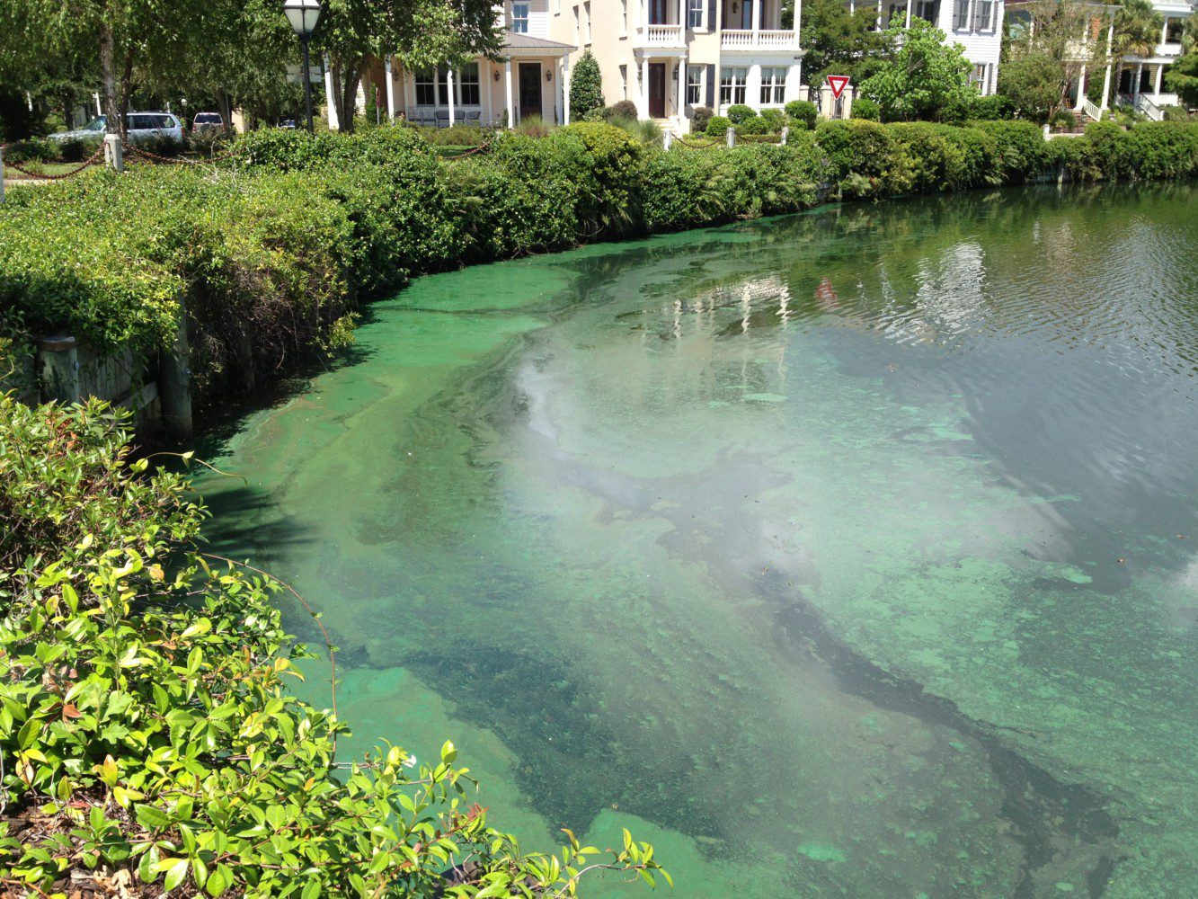
Lab design Scaffolding Worksheet
You come across a pond in your neighborhood. You notice now that the top of the pond is very scummy, with a green film all over it. You don’t remember the pond being this way when you walked by it last week. What could have happened?

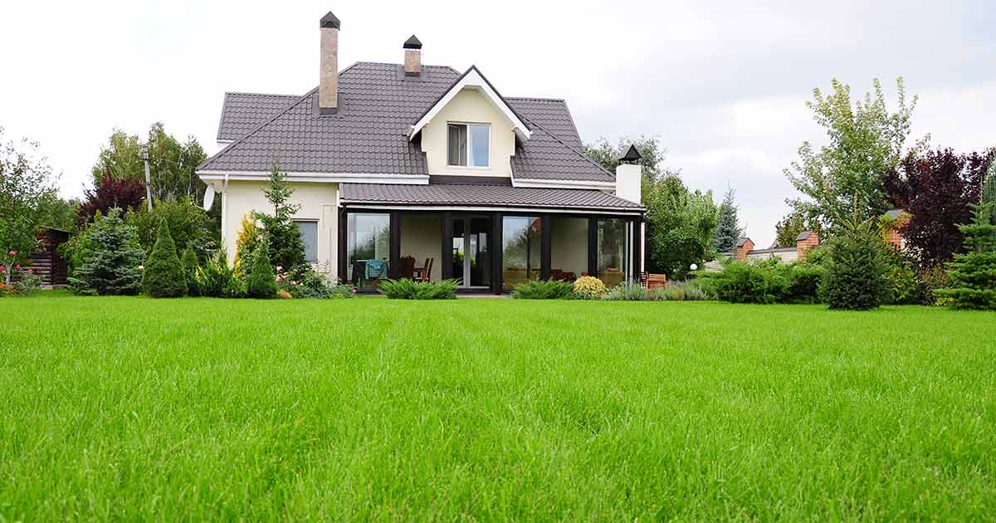

What observations can you make about the area around the pond?

How do the yards look?

What other features are near the pond? Golf courses? Farms? Parks?

You want to find out if the different locations around the pond are contributing to the yucky-ness of the water. Choose one feature from around the pond to model your experiment after.

You learned in class that algae blooms are often caused from excess fertilizer ending up in water.

How often does the feature that you picked get fertilized? Do some internet research to find out.

Does this location get one big shot of fertilizer or many smaller doses of fertilizer?

How much actual fertilizer does this feature use? A lot or a little? Milliliters or liters?

You happen to have some jars at home in which you could model your location in. A model is a representation of something. We can model the different ways that people treat their lawns, farms, and golf courses and see how that might interact with the pond. We can also take into account the weather for the area. Is this a place that rains a lot, or just one big storm every now and again. Taking these things into consideration, there are things you need to decide in order to conduct your experiment.

- Based on your research and observations above, how often do you want to add fertilizer to your pond water sample over the course of two weeks? Explain your reasoning

- Based on your research and observations, how much fertilizer should you add to model your pond. Think about how big your jar is compared to how big the pond is. How do we scale down the model appropriately? Explain your reasoning

- You will have three jars. One jar is your control (just pond water and sunlight). Below describe in a lot of detail how you plan to set up the other two jars.

